Study.com

🎓 Definition
# Source: ScreenShots Source: Provided by: [Persons Table -> ID Column: 1, Name_En Column: Motasem Essam] -> Tool: [Lightshot Program] -> From [Site :https://study.com/] on [11/13/2025]
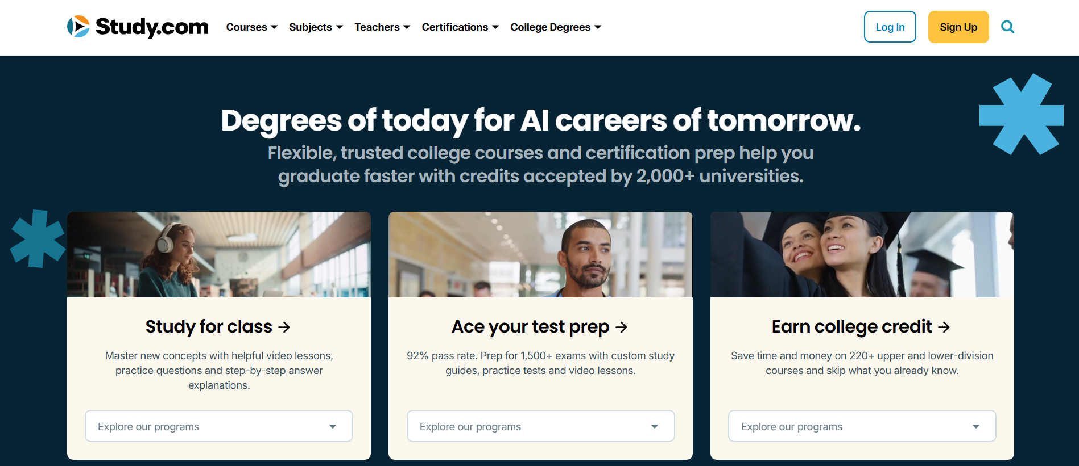
# Source: AI Source: Provided by: [Data Path: Persons Table -> ID Column: 1, Name_En Column: Motasem Essam] -> From: [ChatGPT] on [11/13/2025]
Study.com — https://study.com/ — is an online learning platform that provides educational videos, courses, and study resources for students, teachers, and professionals.
Here’s a full breakdown 👇

📌 Overview
# Source: AI Source: Provided by: [Data Path: Persons Table -> ID Column: 1, Name_En Column: Motasem Essam] -> From: [ChatGPT] on [11/13/2025]
- Study.com is a U.S.-based e-learning website offering video-based lessons and interactive quizzes across a wide range of academic and professional subjects.
- It’s designed for K–12, college, and adult learners, as well as teachers and tutors.
- The site provides structured courses that help users prepare for exams, earn college credit, or supplement school learning.

⚡ Key Features
# Source: AI Source: Provided by: [Data Path: Persons Table -> ID Column: 1, Name_En Column: Motasem Essam] -> From: [ChatGPT] on [11/13/2025]
- Video Lessons: Thousands of short, engaging video lessons explaining academic concepts.
- Courses & Subjects: Covers math, science, business, history, English, computer science, psychology, and more.
- College Credit Opportunities: Many courses are approved by the American Council on Education (ACE) for transferable college credit.
- Test Prep: Resources for standardized tests like SAT, ACT, GRE, Praxis, and CLEP.
- Teacher Resources: Lesson plans, classroom tools, and continuing education materials.
- Certificates & Degree Pathways: Offers online degree partnerships through accredited institutions.

✅ Purpose
# Source: AI Source: Provided by: [Data Path: Persons Table -> ID Column: 1, Name_En Column: Motasem Essam] -> From: [ChatGPT] on [11/13/2025]
To make quality education accessible and affordable by offering flexible, self-paced learning online — useful for students, teachers, and working adults.

🛡️ Safety & Legality
# Source: AI Source: Provided by: [Data Path: Persons Table -> ID Column: 1, Name_En Column: Motasem Essam] -> From: [ChatGPT] on [11/13/2025]
- Fully legal and safe.
- Operated by a legitimate U.S. education company.
- Offers paid subscription plans for full access (some content free).

📌 Summary
# Source: AI Source: Provided by: [Data Path: Persons Table -> ID Column: 1, Name_En Column: Motasem Essam] -> From: [ChatGPT] on [11/13/2025]
Study.com is a legitimate educational platform that provides online learning courses, video lessons, and test prep tools for learners of all ages. It’s safe, legal, and widely used in academic and professional settings.

